Lab 04
Elements of Structured Programming - C++ Basics Part 2 – Simple Flow of Control
Objectives
- Practice coding of simple selections (if and if ... else statements)
- Practice coding of simple loops (while loops and do while loops)
Pre-Lab
Students should try out as many questions in the Revision Exercises and the Extra Exercises sections before coming to the lab, to achieve maximal learning outcome.
Revision Exercises | (20 minutes)
- Given the following code fragment, and an input value of 5, what is the output?
int x;
if( x< 3)
{
cout << "small\n";
}
else
{
if( x < 4)
{
cout << "medium\n";
}
else
{
if( x < 6)
{
cout << "large\n";
}
else
{
cout << "giant\n";
}
}
}
- Write out the output for the following program segment.
int x = 0;
while (x != 5)
x++;
cout << x << endl;
- What is the final value of x after the following fragment of code executes?

int x=0;
do
{
x++;
}while(x > 0);
- Tutor discuss with students on Q15 d, Q16 b, Q19 c, Q22, Q24, Q28 and Q30 from the extra questions at the last section. This should not take more than 15 minutes.

Programming Exercises | (1 hour 40 minutes)
Write a program for every question below. These questions are taken from Lab 3. You should use the flowcharts that you have drawn previously to help you in the coding.
- Write a program to accept three numbers as input and finds the sum and average of these numbers. Display the sum and average in the end.
- Write a program to accept three numbers and display the largest one.
- Write a program to display numbers from 0 to 99. First use a do…while loop, then use a while loop.
- Write a program for calculating the real roots of a quadratic equation using:
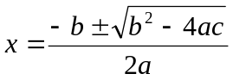
- Write a program that will accept a number, and then display all the numbers from 0 to that number. Modify it so that it only displays odd numbers.
- Write a program to accept a number and compute the sum of all the numbers below that number and above 0.
e.g. 9 → (8+7+6+5+4+3+2+1) = 36
- Write a program to accept a number and output its factorial.
e.g. 5 → 5! = 5x4x3x2x1 = 120
- Write a program to accept two numbers, and then output the result as the first number to the power of the second number.
e.g. 2 5 → 2x2x2x2x2 = 32
- Write a program to accept two numbers and print out the modulus without using the % operator.
e.g. 10 3 → modulus = 1
- Write a program to accept a mark and outputs the grade given the following range of marks and associated grades:
Mark | Grade
90 – 100 | A
80 – 89 | B
70 – 79 | C
50 – 69 | D
0 – 49 | F

- Write a program to calculate the value of ln(1 + x):
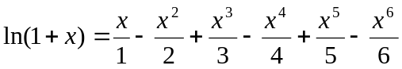
- Write a program to calculate the value of sin(x):
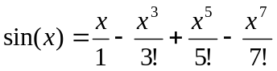
- Write a program to check whether a given number is a prime number or not.
- Write a program to display all the prime numbers below a given number.
e.g. 20 → 3, 5, 7, 11, 13, 17
- Write a program to display the Fibonacci numbers below a given number.
e.g. 20 → 1 1 2 3 5 8 13

Extra Exercises
Try all the questions below.
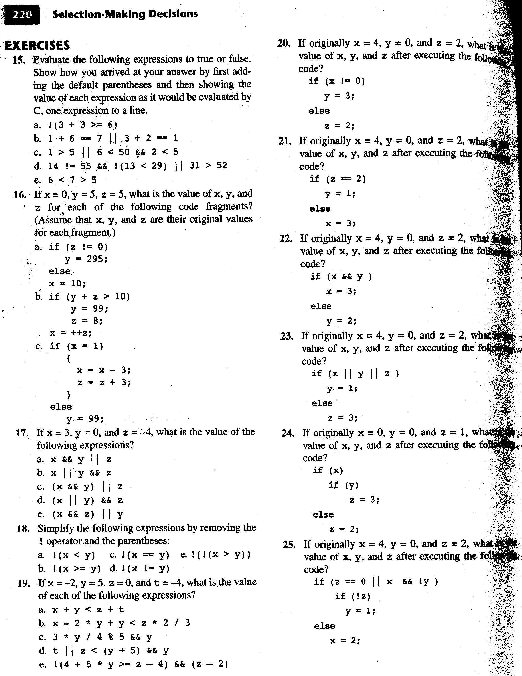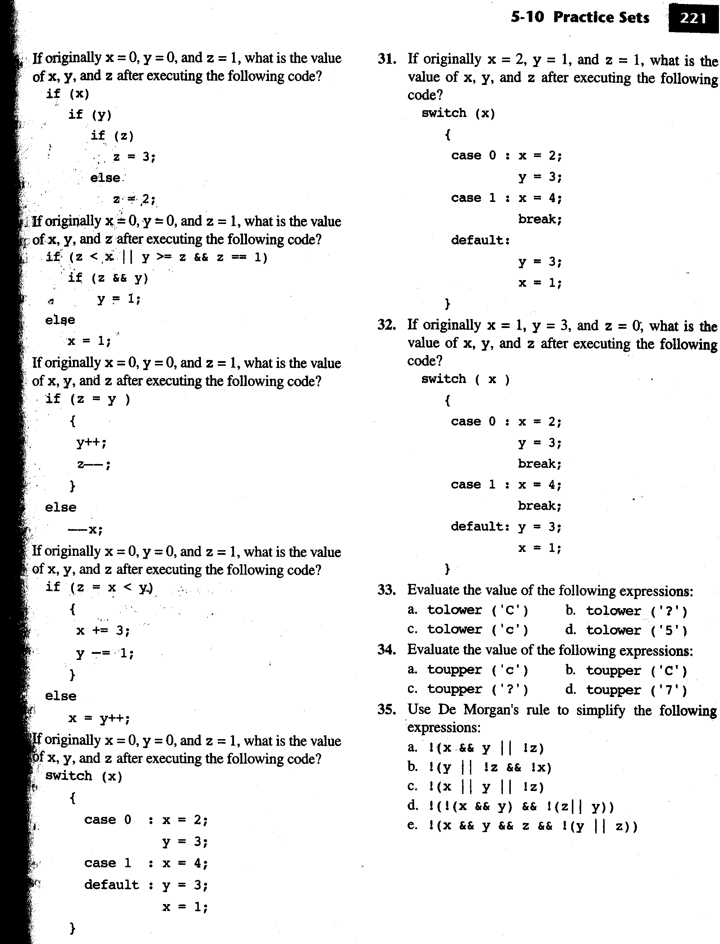
(26)
(27)
(28)
(29)
(30)

